Side Project #1: Productivity in Manufacturing Sector in Indonesia

There has been a resurgence of interest in industrial policy in recent years, highlighting a vital avenue for developing countries to strengthen their industrial capacity and drive economic growth. Firms, as the foundational units of this growth, have long been studied both for how they shape industrial policy and how they benefit from it. In this project, we explore firm-level productivity within the Indonesian manufacturing sector. Because productivity is an abstract concept that is notoriously difficult to measure directly, our analysis centers on estimating Total Factor Productivity (TFP)—a standard economic metric used to evaluate how efficiently a firm converts inputs into outputs.
To accomplish this, we leverage the Industri Besar dan Sedang (Large and Medium Manufacturing, hereinafter IBS) dataset from Statistics Indonesia, covering the period from 2017 to 2022. ur analysis was run on Stata-18 end-to-end. While this study does not evaluate specific industrial policies in the traditional sense, our exploration serves as a practical exercise designed to demonstrate how to:
- Clean and prepare the dataset, including the proper deflation of financial variables.
- Estimate Total Factor Productivity and its corresponding input elasticities.
- Provide descriptive evidence of firm performance and productivity trends.

We begin our exercise with data cleaning. We provide one year example of cleaning IBS below:
* ====================================================
* Data Cleaning & Deflating
* ====================================================

use “ibs2019.dta”, clear

**# Firm ID
describe Kipb
gen double firm_id = real(Kipb)
format firm_id %12.0f
list Kipb firm_id in 1/20, clean
la var firm_id "Firm ID"

**# Year
rename year annual_operation
gen year = 2020
la var year "Year of the Observation"

**# Sector/Disic
gen disic5 = disic520
destring disic5, replace
la var disic5 "Isic Code 5 Digit"

gen disic2 = substr(disic520, 1, 2)
destring disic2, replace force
label variable disic2 "Isic 2 Digit"

* ====================================================
* 1. Firm Output
* ====================================================

**# Firm Income & Output Deflation
local RUN_INCOME_BLOCK 1
if `RUN_INCOME_BLOCK' == 1 {

* 0. Destring raw inputs FIRST
* (In 2020, yprvcu20 is the nominal income, disic2 is the sector code)
destring yprvcu20 disic2, replace

* 1. Generate base nominal output variable (preserves raw survey data)
gen output = yprvcu20

* 2. Drop invalid observations before deflating.
* (Drop non-productive firms and firms missing their sector code)
drop if output == 0 | missing(output)
drop if missing(disic2)

* 3. Generate Sector-Specific IHP Deflator (Base 2010=100) // IHP is sectoral-Indeks Harga Produsen retrieved from BPS
gen ihp2020 = .
replace ihp2020 = 150.43 if disic2 == 10
replace ihp2020 = 163.93 if inlist(disic2, 11, 12)
replace ihp2020 = 153.81 if disic2 == 13
replace ihp2020 = 165.41 if inlist(disic2, 14, 15)
replace ihp2020 = 164.88 if disic2 == 16
replace ihp2020 = 145.55 if inlist(disic2, 17, 18)
replace ihp2020 = 128.78 if disic2 == 19
replace ihp2020 = 138.43 if inlist(disic2, 20, 21)
replace ihp2020 = 123.61 if disic2 == 22
replace ihp2020 = 150.01 if disic2 == 23
replace ihp2020 = 118.50 if disic2 == 24
replace ihp2020 = 130.14 if disic2 == 25
replace ihp2020 = 152.09 if inlist(disic2, 26, 27, 28)
replace ihp2020 = 141.04 if inlist(disic2, 29, 30)
replace ihp2020 = 162.53 if inlist(disic2, 31, 32, 33)

* 4. Deflate the Nominal Output
* Formula: (Nominal / Deflator) * 100
gen real_output = (output / ihp2020) * 100

* 5. Log Transform the REAL output
gen log_output = ln(real_output)

* 6. Apply Labels consistently
la var output "Firm Total Output Nominal (Rp)"
la var ihp2020 "IHP 2020 Deflator (Base 2010=100, by disic2)"
la var real_output "Firm Total Output Real (Deflated by Sector IHP)"
la var log_output "Firm Total Output Real (in Log)"

}

* ====================================================
* 2. Labor
* ====================================================

**# Labor (2020 - Production vs Non-Production)
local RUN_LABOR_BLOCK_20 1
if `RUN_LABOR_BLOCK_20' == 1 {

* 1. Destring all raw inputs FIRST
* 2020 Structure: l = WNI (Local), f = Asing (Foreign)
destring lprnol20 lprnof20 lnpnol20 lnpnof20, replace force

* 2. Generate base labor variables
* Summing WNI and Asing for each category based on the 2020 questionnaire
gen prodlab = lprnol20 + lprnof20
gen non_prodlab = lnpnol20 + lnpnof20
gen labor = prodlab + non_prodlab

* Drop firms with 0 or missing total labor before doing log
drop if labor == 0 | missing(labor)
drop if labor < 20

* 3. Generate log transformations
gen log_labor = ln(labor)
gen log_prodlab = ln(prodlab)
gen log_nonprodlab = ln(non_prodlab)

* 4. Apply variable labels consistently
la var labor "Total Labor"
la var log_labor "Total Labor (in Log)"
la var prodlab "Labor: Production Workers"
la var log_prodlab "Labor: Production Workers (in Log)"
la var non_prodlab "Labor: Non-Production/Other Workers"
la var log_nonprodlab "Labor: Non-Production/Other Workers (in Log)"

gen size = .
replace size = 0 if labor >= 20 & labor <= 99
replace size = 1 if labor >= 100

la def lbl_size_20 0 "Medium Firm" 1 "Large Firm"
la val size lbl_size_20
la var size "Firm Size (Categorical)"

*Destring the "Jumlah" (Total) rows for Production and Non-Production
destring zpdvcu20 zndvcu20, replace force

* Handle missing values before summing
replace zpdvcu20 = 0 if missing(zpdvcu20)
replace zndvcu20 = 0 if missing(zndvcu20)

* 3. Generate Total Labor Cost (Wage Bill)
gen labor_cost = zpdvcu20 + zndvcu20
gen log_labor_cost = ln(labor_cost + 1)
gen prod_cost = zptvcu20
gen log_prodcost = ln(prod_cost)
gen nonprod_cost = zntvcu20
gen log_nonprodcost = ln(nonprod_cost)

la var labor_cost "Total Labor Cost Nominal (Rp 000)"
la var log_labor_cost "Total Labor Cost Nominal (in Log)"
la var prod_cost "Total Labor Cost for Production Worker (Rp 000)"
la var nonprod_cost "Total Labor Cost for Non-Production Worker (Rp 000)"
la var log_prodcost "Total Labor Cost for Production Worker (in Log)"
la var log_nonprodcost "Total Labor Cost for Non-Production Worker (in Log)"

* 5. Apply variable labels
la var labor_cost "Total Labor Cost Nominal (Rp 000)"
la var log_labor_cost "Total Labor Cost Nominal (in Log)"
}

* ====================================================
* 3. Capital
* ====================================================

**# Capital
local RUN_CAPITAL_BLOCK 1
if `RUN_CAPITAL_BLOCK' == 1 {

// -- Flow: (1) Impute Initial Capital with End Capital (V1115);
// (2) Impute Firm that Leases Capital (IBRVCU);
// (3) Drop Capital if still Zero;
// (4) Deflate with IHBP (UMUM);
// (5) Log Transform

* 0. Destring raw inputs first to prevent type mismatch errors
destring ctfpcu20 v1115 ibrvcu20, replace force

* 1 & 2. Generate base capital and impute missing/zero values
gen capital = ctfpcu20
replace capital = v1115 if capital == 0 & v1115 > 0 & !missing(v1115)
replace capital = ibrvcu20 / 0.10 if capital == 0 & ibrvcu20 > 0 & !missing(ibrvcu20)

* 3. Drop invalid capital observations
drop if capital == 0 | missing(capital)

* 4. Deflate capital (FIXED: Now uses the imputed 'capital' instead of raw 'ctfpcu20')
gen real_capital = (capital / 103.55) * 100

* 5. Log Transform
gen log_capital = ln(real_capital)

* 6. Apply Labels consistently
la var capital "Firm Capital (Rp)"
la var real_capital "Firm Capital (Deflated with IHPB Umum)"
la var log_capital "Firm Capital (in Log)"

}

* ====================================================
* 4. Raw Materials and Input
* ====================================================

**# Raw Materials & Input
local RUN_INPUT_BLOCK 1
if `RUN_INPUT_BLOCK' == 1 {

* 0. Destring raw inputs FIRST
destring rtlvcu20 eplvcu20, replace force

gen raw_material = rtlvcu20

* Drop invalid observations (safely catch zeros AND missing values)
drop if raw_material == 0 | missing(raw_material)

* Deflate Nominal with Indeks Harga Perdagangan Besar (IHPB) (2020 Value is 104.30)
gen real_materials = (raw_material / 104.30) * 100
gen log_material = ln(real_materials)

* Label variables
la var raw_material "Raw Materials (Rp)"
la var real_materials "Raw Materials (Deflated with IHPB)"
la var log_material "Raw Materials (in Log)"

gen electricity = eplvcu20

* Generate log transformation
gen log_electricity = ln(electricity)

* Label variables
la var electricity "Electricity Cost (Rp)"
la var log_electricity "Electricity Cost (in Log)"

}

Upon finish cleaning, we then merge 2017 to 2022 dataset utilizes this syntax
*============================================================*
* Append Annual Manufacturing Data (2017–2022)
*============================================================*

clear all
set more off

* Load the initial dataset
use "ibs 2017.dta", clear

* Append subsequent annual datasets
foreach yr of numlist 2018/2022 {
append using "ibs `yr'.dta"
}

*============================================================*
* Panel Data Preparation
*============================================================*

* Sort observations by firm identifier and year
sort firm_id year

* Define variable labels
label variable firm_id "Firm Unique Identifier"
label variable year "Year of Observation"

* Declare panel structure
xtset firm_id year

* Examine panel structure
xtdescribe

Following the data appending and cleaning processes, Table 1 presents the descriptive statistics for the variables used in our TFP estimation. The key variables are defined as follows:
- Output: Real output, which was deflated during the data preparation phase.
- Labor: The combined total of production and non-production workers.
- Capital: The firm's total capital stock.
- Materials: The raw materials utilized in the production process.
All variables are expressed in natural logarithms.
Table 1 Descriptive statistic
Variable Name | Description | Obs | Mean | Std. Dev. | Min | Max
Log_output | Real Output (in Log) | 148,617 | 16.453 | 2.096 | 4.795 | 24.980
Log_labor | Labor (in Log) | 148,617 | 4.293 | 1.211 | 0 | 10.920
Log_prodlab | Production Labor (in Log) | 148,617 | 4.094 | 1.226 | 0 | 10.844
Log_nonprodab | Non-Production Labor (in Log) | 127,110 | 2.488 | 1.351 | 0 | 9.485
Log_capital | Capital Stock (in Log) | 148,617 | 14.088 | 2.634 | 1.839 | 26.592
Log_material | Intermediate Materials (in Log) | 148,617 | 15.670 | 2.290 | 3.423 | 24.704

Which we created from:
use "appended 2017-2022.dta", clear

xtset firm_id year
sum log_output log_labor log_prodlab log_nonprodlab log_capital log_material

We estimate firm-level TFP using the method developed by Levinsohn and Petrin (2003). Assuming a Cobb–Douglas production technology with two categories of labor inputs, this approach leverages intermediate inputs—specifically raw materials, in our case—as a proxy for unobserved productivity shocks, rather than relying on investment. The production function is specified as follows:
$$\ln{Y_{it}}=β_{1}\ln{L^{P}}it+β_{2}\ln{L^{NP}}it+β_{3}\ln{M_{it}}+β_{4}\ln{K_{it}}+ω_{it}+ε_{it}$$

where$\left(i\right)$ and $\left(t\right)$ denote firm and year, respectively. $\left(Y_{it}\right)$ represents firm-level output, while $\left(L^{P}it\right)$ and $\left(L^{NP}it\right)$ denote productive and non-productive labor inputs, respectively. $\left(M_{it}\right)$ represents intermediate material inputs, and $\left(K_{it}\right)$ denotes the capital stock. The coefficients $\left(β_{1}\right)$, $\left(β_{2}\right)$, $\left(β_{3}\right),$ and $\left(β_{4}\right)$ represent the output elasticities of their respective production inputs. The term $\left(ω_{it}\right)$ captures firm-level productivity, which is observed by the firm but unobserved by the econometrician, while $\left(ε_{it}\right)$ represents an idiosyncratic error term.
We estimated this through:
prodest log_output, free(log_prodlab log_nonprodlab) proxy(log_material) state(log_capital) id(firm_id) t(year)method(lp) fsresiduals(fsr)
predict tfp_lp, omega
sum tfp_lp

Table 2 presents the estimated production input elasticities. Intermediate materials have the largest output elasticity (0.685), followed by non-production labor (0.131), production labor (0.121), and capital stock (0.016). All coefficients are statistically significant at the 1% level. The estimated returns to scale of 0.9535 suggest slightly decreasing returns to scale. Furthermore, the Wald test rejects constant returns to scale at the 1% significance level.
With an estimated elasticity of 0.685, intermediate materials account for the largest production elasticity, substantially exceeding those of both production and non-production labor, as well as capital. This pattern may reflect the relatively material-intensive nature of Indonesian manufacturing, where production remains heavily dependent on raw materials and intermediate inputs rather than capital accumulation or labor expansion alone. In this context, the availability, quality, and efficient utilization of intermediate materials may play a particularly important role in shaping firm-level production performance.
Table 2 TFP Elasticities
Input | Coeff.
Production Labor | 0.121***
 | (0.001)
Non-Production Labor | 0.131***
 | (0.001)
Capital Stock | 0.016***
 | (0.000)
Intermediate Materials | 0.685***
 | (0.004)
Model Diagnostics & Tests
Returns to Scale $\left(\sum{}\hat{β}\right)$ | 0.9535
Wald Test for CRS $(χ^{})$ | 90.04***
Observations | 126,976
Period | 2017-2022
Notes: *** p<0.01, p<0.05, * p<0.10. Standard errors are reported in parentheses. The model is estimated using the Levinsohn-Petrin (2003) control function approach, using intermediate materials as a proxy for unobserved productivity shocks to address simultaneity bias. Returns to scale represent the sum of the estimated elasticities for labor, capital, and materials.
One practical example would be an Indonesian garment or textile manufacturer.
Consider a garment factory producing shirts for domestic and export markets. Its production depends on several inputs:
- Production labor: Sewing operators, cutting workers, and garment assemblers who directly manufacture the shirts.
- Non-production labor: Administrative staff, accountants, supervisors, and warehouse managers.
- Capital stock: Sewing machines, cutting equipment, factory buildings, and other machinery.
- Intermediate materials: Fabric, thread, buttons, zippers, labels, and packaging materials.
Even if the factory has sufficient workers and machinery, it cannot maintain production without a reliable supply of fabric and other materials. A disruption in fabric supply, for example, could leave sewing machines idle and workers unable to complete orders. This illustrates why intermediate materials may have a particularly large output elasticity in our estimation. Indonesian manufacturing firms may rely heavily on the continuous availability of raw materials and intermediate inputs to sustain production, making material procurement and utilization particularly important to their production performance.
Moving onward, we further showcase TFP level across the indicated years on Figure 1 through a syntax of:
**# TFP Level (Mean) across the years
{
preserve
* 1. Collapse to annual Mean and Standard Error components
collapse (mean) mean_tfp = tfp_lp (sd) sd_tfp = tfp_lp (count) n = tfp_lp, by(year)
drop if missing(year)
* 2. Calculate 95% Confidence Intervals for the Mean
gen ci_high = mean_tfp + 1.96 * (sd_tfp / sqrt(n))
gen ci_low = mean_tfp - 1.96 * (sd_tfp / sqrt(n))
* 3. Generate Plot
graph set window fontface "Times New Roman"
set scheme s1mono
twoway ///
/// 95% CI Error Bars (Plotted first so caps sit behind the marker)
(rcap ci_low ci_high year, ///
lcolor(gs7) lwidth(medthick) msize(medium)) ///
/// Mean Trend Line
(connected mean_tfp year, ///
lcolor(black) mcolor(black) msymbol(O) lpattern(solid) lwidth(thick) msize(medium)), ///
/// Axes Titles and Formatting
ytitle("Log TFP Level (Levinsohn-Petrin)", size(medium) margin(right)) ///
xtitle("Year", size(medium) margin(top)) ///
/// Tightly bound the Y-axis to maximize visibility of the micro-movements
ylabel(4.65(0.05)4.80, angle(0) nogrid labsize(small) format(%9.2f)) ///
xlabel(2017(1)2022, nogrid labsize(small)) ///
/// Legend Box Styling
legend(order(2 "Mean TFP" 1 "95% Confidence Interval") ///
rows(1) position(6) region(lstyle(none)) size(small)) ///
/// Canvas Dimensions & True White Background
graphregion(color(white) fcolor(white) lcolor(white) margin(medium)) ///
plotregion(color(white) fcolor(white) lcolor(black) lwidth(medium)) ///
ysize(5) xsize(7) ///
graph export "Fig - TFP Level 2017-2022.png", replace width(3600)
restore
}
We observe a steady increase in productivity from 2017, reaching its peak in 2020, followed by a gradual decline through 2022. Interestingly, the upward trend persisted during the initial COVID-19 period, potentially reflecting firms' adjustments in production processes or changes in the composition of surviving firms. However, the subsequent decline suggests that these productivity gains were not fully sustained in the following years.
Figure 1 TFP Level across the years
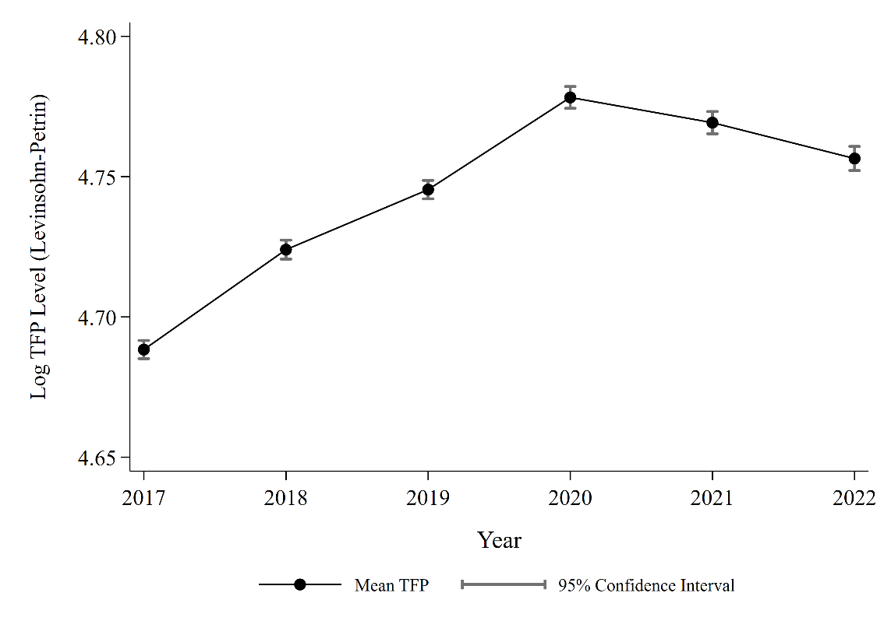
Notes: Whisker shows 95% CI. Source: Author’s own calculation.
Figure 2 further reveals that aggregate productivity trends mask a persistent gap between the most productive and least productive firms. The 90th percentile firms consistently outperform those at the 10th percentile, with the productivity gap widening from 2017 and reaching its peak of 0.64 log points in 2020. Interestingly, while frontier firms experienced productivity gains until 2020, laggard firms recorded only modest improvements over the same period. Following 2020, productivity among frontier firms began to decline, while laggard firms remained relatively stagnant. This suggests that productivity improvements in Indonesian manufacturing have been unevenly distributed, with leading firms driving much of the overall productivity growth rather than broad-based improvements across the sector.
Figure 2 Productivity gap between frontier and laggard firms
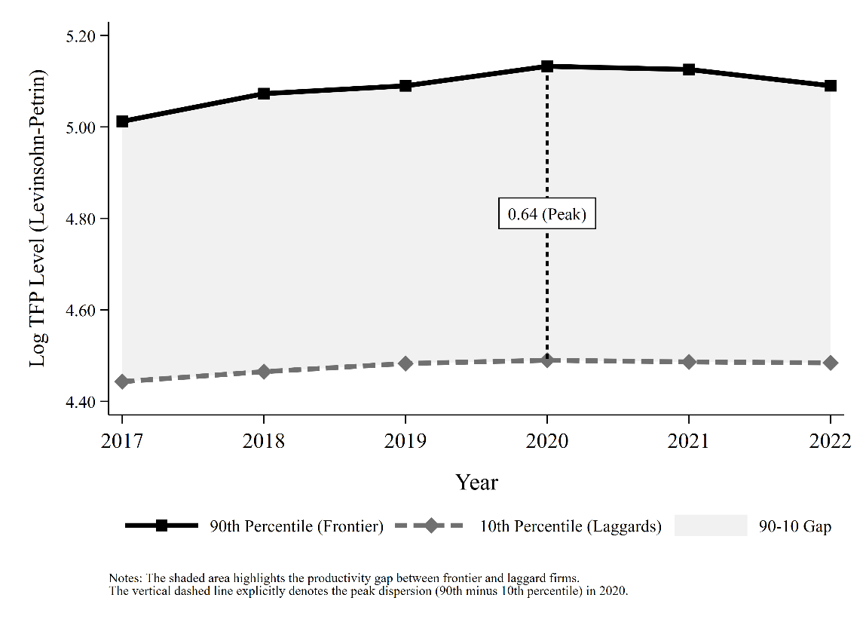
Notes: The shaded area highlights the productivity gap between frontier and laggard firms. The vertical dashed line explicitly denotes the peak dispersion (90th minus 10th percentile) in 2020. Source: Author’s own calculation.
The syntax for Figure 2 is:
**# TFP Dispersion
{
preserve
* 1. Collapse to annual 90th and 10th percentiles
collapse (p90) p90_tfp = tfp_lp (p10) p10_tfp = tfp_lp, by(year)
drop if missing(year)
sort year
quietly summarize p90_tfp if year == 2020
local y90 = r(mean)
quietly summarize p10_tfp if year == 2020
local y10 = r(mean)

* Calculate the gap value and the vertical midpoint for the label
local gap_val = `y90' - `y10'
local ymid = (`y90' + `y10') / 2

* Format the gap to 2 decimal places as a string
local gap_str : display %9.2f `gap_val'
local gap_str = trim("`gap_str'")

* 3. Generate Plot
graph set window fontface "Times New Roman"
set scheme s1mono

twoway ///
/// A. Shaded area representing the productivity gap (Darkened to gs12 for visibility)
(rarea p90_tfp p10_tfp year, ///
fcolor(gs12) lcolor(none)) ///
/// B. The 90th Percentile (Frontier)
(connected p90_tfp year, ///
lcolor(black) mcolor(black) msymbol(S) lpattern(solid) lwidth(thick) msize(medium)) ///
/// C. The 10th Percentile (Laggards)
(connected p10_tfp year, ///
lcolor(gs7) mcolor(gs7) msymbol(D) lpattern(dash) lwidth(thick) msize(medium)) ///
/// D. Vertical dashed connector line specifically for 2020
(scatteri `y90' 2020 `y10' 2020, ///
connect(line) msymbol(none) lcolor(black) lpattern(shortdash) lwidth(medthick)), ///
/// E. Text label inside a white box positioned at the 2020 midpoint
text(`ymid' 2020 "`gap_str' (Peak)", box fcolor(white) lcolor(black) margin(small) size(small)) ///
/// Axes Titles and Formatting
ytitle("Log TFP Level (Levinsohn-Petrin)", size(medium) margin(right)) ///
xtitle("Year", size(medium) margin(top)) ///
ylabel(, angle(0) nogrid labsize(small) format(%9.2f)) ///
xlabel(2017(1)2022, nogrid labsize(small)) ///
/// Legend Box Styling
legend(order(2 "90th Percentile (Frontier)" 3 "10th Percentile (Laggards)" 1 "90-10 Gap") ///
rows(1) position(6) region(lstyle(none)) size(small) colgap(4)) ///
/// Canvas Dimensions & Enforced White Background
graphregion(color(white) fcolor(white) lcolor(white) margin(medium)) ///
plotregion(color(white) fcolor(white) lcolor(black) lwidth(medium)) ///
ysize(5) xsize(7) ///
graph export "Fig - Dispersion.png", replace width(4000)

restore
}

We continue our exercise by exploring heterogeneity of Return to Scale (RTS) for 2 digit-sector firm productivity. Figure 3 highlights substantial heterogeneity in returns to scale across Indonesian manufacturing subsectors. While several industries exhibit estimates close to constant returns to scale (RTS = 1), others display noticeably different production characteristics. Paper, non-metallic minerals, and motor vehicles exhibit estimates above unity, suggesting potential increasing returns to scale. Conversely, beverages, leather, rubber and plastics, and electrical equipment display relatively lower estimates, indicating decreasing returns to scale. Interestingly, this variation suggests that manufacturing productivity is not driven by a uniform production structure across industries. Rather, the extent to which firms benefit from expanding their production scale appears to depend on the characteristics of their respective subsectors.
Figure 3 Sectoral RTS
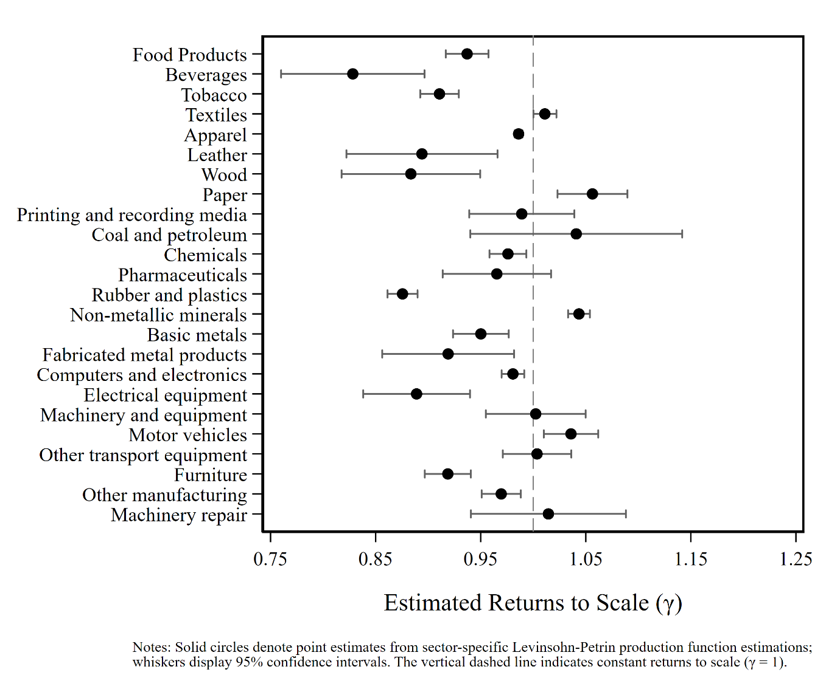
Notes: Solid circles denote point estimates from sector-specific LP production function estimations; whiskers display 95% CI. The vertical dashed line indicates constant RTS $\left(y=1\right)$. Source: Author’s own calculation.
The syntax for Figure 3 was:
{
preserve

* 1. Identify all industries
levelsof disic2, local(sectors)

* 2. Prepare results file
tempname results
tempfile sector_results

postfile `results' ///
int disic2 ///
double beta_prodlab beta_nonprodlab ///
beta_capital beta_material ///
rts rts_se p_crs ///
long N ///
using `sector_results', replace

* 3. Estimate production function by industry
foreach s of local sectors {

capture drop fsr

capture quietly prodest log_output ///
if disic2 == `s', ///
free(log_prodlab log_nonprodlab) ///
proxy(log_material) ///
state(log_capital) ///
id(firm_id) ///
t(year) ///
method(lp) ///
fsresiduals(fsr)

if !_rc {

* Extract coefficients
local bl1 = _b[log_prodlab]
local bl2 = _b[log_nonprodlab]
local bk = _b[log_capital]
local bm = _b[log_material]

local n = e(N)

* Calculate RTS and standard error
quietly lincom ///
log_prodlab + log_nonprodlab + ///
log_capital + log_material

local rts = r(estimate)
local se = r(se)

* Test constant returns to scale
quietly test ///
log_prodlab + log_nonprodlab + ///
log_capital + log_material = 1

local p = r(p)

* Store results
post `results' ///
(`s') (`bl1') (`bl2') (`bk') (`bm') ///
(`rts') (`se') (`p') (`n')
}
}

* 4. Close results file
postclose `results'

* 5. Load results
use `sector_results', clear

* 6. Calculate 95% confidence intervals
gen ci_low = rts - 1.96*rts_se
gen ci_high = rts + 1.96*rts_se

* 7. Label industries
label define sectorlbl ///
10 "Food Products" ///
11 "Beverages" ///
12 "Tobacco" ///
13 "Textiles" ///
14 "Apparel" ///
15 "Leather" ///
16 "Wood" ///
17 "Paper" ///
18 "Printing and recording media" ///
19 "Coal and petroleum" ///
20 "Chemicals" ///
21 "Pharmaceuticals" ///
22 "Rubber and plastics" ///
23 "Non-metallic minerals" ///
24 "Basic metals" ///
25 "Fabricated metal products" ///
26 "Computers and electronics" ///
27 "Electrical equipment" ///
28 "Machinery and equipment" ///
29 "Motor vehicles" ///
30 "Other transport equipment" ///
31 "Furniture" ///
32 "Other manufacturing" ///
33 "Machinery repair"

label values disic2 sectorlbl

* 8. Visualize sectoral RTS
graph set window fontface "Times New Roman"
set scheme s1mono
twoway ///
(rcap ci_low ci_high disic2, ///
horizontal lcolor(gs6) lwidth(medthin) msize(small)) ///
(scatter disic2 rts, ///
mcolor(black) msymbol(O) msize(medsmall)), ///
xline(1, lcolor(gs8) lpattern(dash) lwidth(thin)) ///
xscale(range(0.75 1.25)) ///
xlabel(0.75(0.1)1.25, labsize(small) format(%4.2f) grid gstyle(smalldash) glcolor(gs14)) ///
///
yscale(reverse range(9.5 33.5)) ///
ylabel(10(1)33, valuelabel angle(0) labsize(vsmall) nogrid) ///
xtitle("Estimated Returns to Scale ({&gamma})", size(small) margin(top)) ///
ytitle("") ///
legend(off) ///
graphregion(color(white) fcolor(white) margin(l=18 r=5 t=5 b=5)) ///
plotregion(lcolor(black) fcolor(white) lwidth(medium)) ///
ysize(7) xsize(9) ///

graph export "Fig - Sectoral RTS.png", replace width(3000)

restore

Lastly, we investigate elasticities comparing two manufacturing sectors that often arguably as material intensive and labor intensive. Figure 4 further explores differences in production input elasticities between two manufacturing subsectors with distinct production characteristics: textiles (ISIC 14) and motor vehicles (ISIC 29). Interestingly, intermediate materials remain the largest contributor to output elasticity in both industries, with estimates of 0.792 for textiles and 0.685 for motor vehicles. However, the two sectors exhibit contrasting labor input structures. Motor vehicle manufacturing demonstrates a considerably higher production labor elasticity (0.294) compared to textiles (0.069), suggesting a greater relative contribution of direct production workers to output. Conversely, textiles exhibit a higher non-production labor elasticity (0.152), compared to only 0.023 in motor vehicles. Capital stock contributes relatively little to output elasticity in both sectors. These differences highlight how production structures vary across manufacturing industries. While textile manufacturing appears particularly material-intensive, motor vehicle manufacturing exhibits a relatively stronger reliance on direct production labor. Nevertheless, the substantial contribution of intermediate materials in both industries underscores the importance of material inputs in Indonesian manufacturing production.
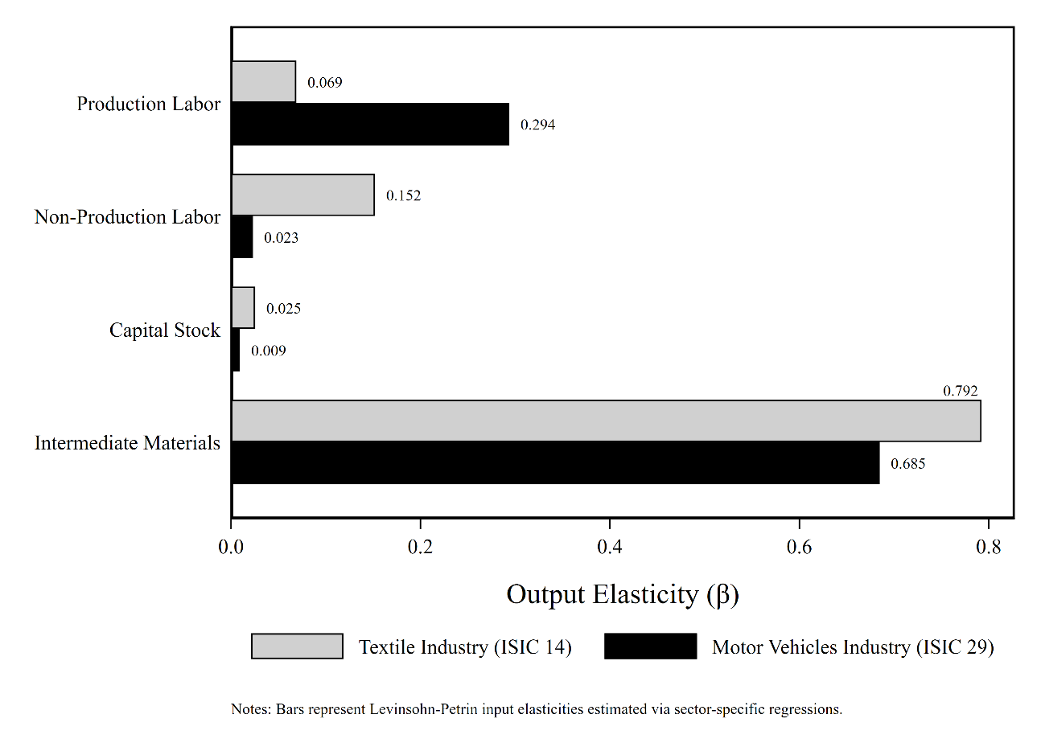
Notes: Bars represent LP input elasticities estimated via sector-specific regressions.
Figure 4 was estimated through:
{
preserve
* 1. Prepare results file
tempname results
tempfile sector_results

postfile `results' ///
int disic2 ///
str25 sector_name ///
double beta_prodlab beta_nonprodlab beta_capital beta_material ///
using `sector_results', replace

* 2. Loop specifically over Textiles (13) and Motor Vehicles (29)
foreach s in 13 29 {

local sname = ""
if `s' == 13 local sname = "Textile Industry"
if `s' == 29 local sname = "Motor Vehicles Industry"

capture drop fsr
capture quietly prodest log_output ///
if disic2 == `s', ///
free(log_prodlab log_nonprodlab) ///
proxy(log_material) ///
state(log_capital) ///
id(firm_id) ///
t(year) ///
method(lp) ///
fsresiduals(fsr)

if !_rc {
* Store coefficients
local bl1 = _b[log_prodlab]
local bl2 = _b[log_nonprodlab]
local bk = _b[log_capital]
local bm = _b[log_material]

post `results' (`s') ("`sname'") (`bl1') (`bl2') (`bk') (`bm')
}
}

postclose `results'

* 3. Load results back into memory
use `sector_results', clear

* 4. Reshape long for grouped bar chart formatting
rename beta_prodlab b_1_prodlab
rename beta_nonprodlab b_2_nonprodlab
rename beta_capital b_3_capital
rename beta_material b_4_material

reshape long b_, i(disic2 sector_name) j(input) string
rename b_ elasticity

gen input_id = .
replace input_id = 1 if input == "1_prodlab"
replace input_id = 2 if input == "2_nonprodlab"
replace input_id = 3 if input == "3_capital
replace input_id = 4 if input == "4_material”

label define inputlbl 1 "Production Labor" 2 "Non-Production Labor" 3 "Capital Stock" 4 "Intermediate Materials"
label values input_id inputlbl

* 5. Generate the chart
graph set window fontface "Times New Roman"
set scheme s1mono

graph hbar (mean) elasticity, ///
over(sector_name, label(labsize(small))) ///
over(input_id, label(labsize(medium))) ///
asyvars ///
bar(1, fcolor(gs13) lcolor(black) lwidth(thin)) /// Textiles (Light Gray)
bar(2, fcolor(black) lcolor(black) lwidth(thin)) /// Motor Vehicles (Solid Black)
blabel(bar, format(%9.3f) size(vsmall)) ///
ytitle("Output Elasticity ({&beta})", size(medium) margin(top)) ///
ylabel(0(0.2)0.8, nogrid labsize(small) format(%3.1f)) ///
legend(order(1 "Textile Industry (ISIC 14)" 2 "Motor Vehicles Industry (ISIC 29)") ///
rows(1) position(6) region(lstyle(none)) size(small)) ///
graphregion(color(white) fcolor(white) margin(medium)) ///
plotregion(lcolor(black) fcolor(white) lwidth(medium)) ///
ysize(5) xsize(7) ///
graph export "Fig – Elasticities Two Sectors.png", replace width(3600)
restore

}

This project provides a descriptive examination of firm-level productivity in Indonesian manufacturing using the IBS dataset covering 2017–2022. Applying the Levinsohn–Petrin approach, we estimate firm-level TFP and explore several characteristics of manufacturing performance. Our findings reveal that intermediate materials exhibit the largest output elasticity among production inputs, highlighting the material-intensive nature of Indonesian manufacturing. Aggregate TFP increased between 2017 and 2020 before gradually declining through 2022. However, these aggregate trends mask considerable disparities between firms, with the productivity gap between frontier and laggard firms reaching its peak in 2020. Furthermore, returns to scale and input elasticities vary substantially across manufacturing subsectors, suggesting that firms operate under different production structures and resource requirements.
Taken together, these findings highlight that strengthening manufacturing capacity requires more than simply increasing production inputs; it also involves improving how firms combine and utilize their resources. For developing economies such as Indonesia, understanding sector-specific production characteristics, improving access to intermediate inputs, and addressing productivity disparities between leading and lagging firms can provide a useful starting point for industrial development discussions. Although this project does not establish causal relationships between industrial policies and firm productivity, it demonstrates the practical value of firm-level productivity analysis in identifying structural characteristics and performance differences within the manufacturing sector.

